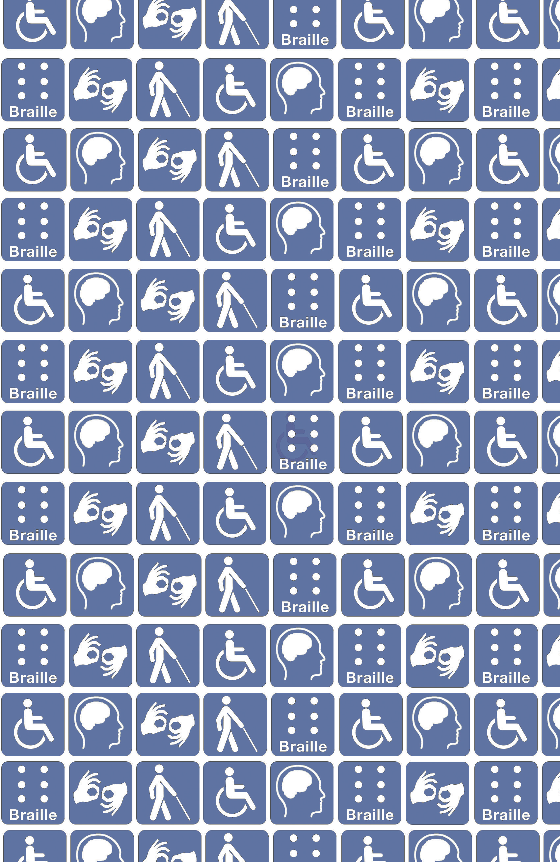

Serving All:
A Guide to Being Accessible for
Your Customers and Community

About This Guidebook

Did you know that over 70,000 people in Washington, DC have a disability? Making sure your restaurant is accessible for all customers is an easy thing to do and good business practice. This guide can assist you to improve accessi- bility in your restaurant, and help increase your sales by distinguishing your restaurant as a welcoming and inclusive place for all patrons.

This guidebook was developed by the American Association of People with Disabilities (AAPD), the nation’s largest disability rights organization, in part- nership with the District of Columbia Office of Human Rights and the District of Columbia Office of Disability Rights. Additional assistance was provided by the District of Columbia Department of Consumer and Regulatory Affairs and the Restaurant Association of Metropolitan Washington. For additional information, visit www.aapd.com.
Contents
03 Why is Accessibility a Good Idea?
05 What is an Accessible Restaurant?
07 Best Practices
11 How Accessibility Friendly Are You?
13 Resources

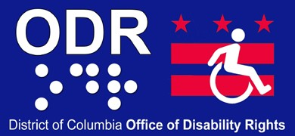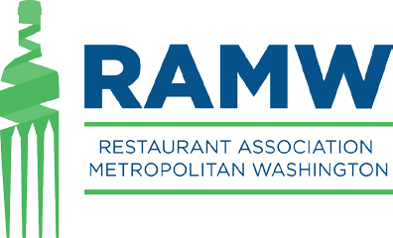

2

Why is Accessibility a Good Idea?
Making your restaurant accessible has never been better for business.

Over 11 percent of Washington, DC residents live with a disability. That’s over 70,000 customers who could be coming to your restaurant – and that does not in- clude the many visitors with disabilities who come to DC from across the nation and around the world.

Customers with disabilities include people who use wheelchairs, walkers, canes, and scooters to get around, people who are blind and low vision, deaf and hard-of- hearing, and even those with sensitivity to the environment, such as smell or light sensitivity.

It is not uncommon for customers with disabilities to turn away from restaurants because of a narrow doorway or the lack of a ramp. Others decide not to eat at an establishment because they do not wish to go through the kitchen or trash room to get to their table.

Think About It!
If your restaurant has just one step, you are cutting off an entire customer base from spending money at your restaurant, and are therefore losing additional revenue.

People with disabilities go out and spend money. They have lunch with friends, take their families out to dinner, and go to happy hour with work colleagues. In fact, peo- ple with disabilities have a spending power of $220 billion annually.

Further, 75 percent of people with disabilities are reported to eat out at least once a week, and spend over $35 billion in restaurants a year. The total na- tional spending of travelers with disabilities exceeds $13.6 billion annually. The District attracts many residents and visitors with disabilities, and their purchasing power is significant.

Washington, DC is a city that attracts a large number of people with disabilities from across the nation and around the world. Many individuals come to work for the federal government, which is a model employer of people with disabilities, and to work for many national organizations headquartered in the area.

As the purchasing power of customers with disabilities grows, restaurant acces- sibility is no longer just about compliance with federal and DC law. It is the right thing to do for restaurants that want to attract new customers and keep their current ones coming back.

Did You Know?
It is no surprise that with the boom of smart phones, the use of mobile soft- ware applications (“apps”), to rate and navigate accessible restaurants has skyrocketed. If your restaurant is completely accessible, word will spread quickly and your consumer base will grow significantly – not just for people with disabilities, but for the friends and family who go out with them as well.

3 4

What is an Accessible Restaurant?

Accessibility means making your restaurant comfortable for everyone. It in- volves creating a welcoming environment, and removing any physical barriers out- side and inside the restaurant. Here are some key elements of creating an accessi- ble and welcoming environment in your restaurant:
BEST PRACTICES FOR ACCESSIBILITY
WELCOMING ATMOSPHERE  - Good customer service  - Inclusive policies | OUTSIDE THE RESTAURANT  - Accessible entrances  - Accessible parking
INSIDE THE RESTAURANT  - Accessible bathrooms  - Accessible table & counter height  - Accessible paths to travel | VIRTUAL ENTRANCE  - Accessible website  - Online ordering  - Online reservations

This definition of alterations, written by the United States Access Board, can help you in considering accessibility when making alterations:
“A change to a building or facility that affects or could affect the usability of the building or facility or portion thereof. Alterations include, but are not limited to, remodeling, renovation, rehabilitation, reconstruction, historic res- toration, resurfacing of circulation paths or vehicular ways, changes or rear- rangement of the structural parts or elements, and changes or rearrangement in the plan configuration of walls and full-height partitions. Normal mainte- nance, re-roofing, painting or wallpapering, or changes to mechanical and electrical systems are not alterations unless they affect the usability of the building or facility.”

Accessibility is a continuum and goes beyond simply the physical environment. Creating a welcoming atmosphere with well-trained staff, sound policies and an accessible website can open your doors – and increase sales – to customers with disabilities.

Accessibility is often easy to do and inex- pensive, and can include financial assis- tance from the federal government. Small businesses are eligible for a tax credit (max- imum $5,000) to offset costs and all busi- nesses are eligible for a tax deduction up to
$15,000 per year.

Whether you are newly constructed or under- going alterations, be sure to make your restau- rant accessible. Alterations are a perfect time to increase the accessibility of your restaurant and can be required by law. Making your restaurant accessible is generally a fraction of the costs of your alterations. Even if your restaurant was built before 1990 when federal regulations on accessibility were first enacted, accessibility is still a commitment all restaurants must main- tain.

5 6

Implementing inclusive policies

- Display signage at any inaccessible entrance that directs customers to the near- est accessible entrance.

- When barrier removal is not possible for your entrance, provide curbside service
and an accessible ringer outside the restaurant.

- Allow service animals, such as seeing-eye-dogs and hearing-assist-dogs.

Best Practices

Create a Welcoming Atmosphere

Creating an inclusive, welcoming atmosphere for customers with disabilities is a good business decision and is likely simpler than you imagine.

Tips on customer service for people with disabilities

- Ask before you help. Do not assume that people with disabilities need extra as- sistance. If the setting is accessible, people with disabilities can usually get around independently. Adults with disabilities want to be treated as independent people. A person with a disability will oftentimes communicate when help is necessary.

- Take steps necessary to communicate effectively with customers with vision, hearing, and speech disabilities. It can be as simple as having a waiter read the menu to the patron.

- Respond graciously to requests. When people with disabilities ask for an ac- commodation at your business, this is not a complaint. Rather, this action shows that a person with a disability feels comfortable enough at your establishment to ask for necessary assistance.

- Speaking directly to the patron, not to his or her companion, aide or sign lan- guage interpreter, is a preferred method of contact.

- Be sensitive about physical contact. Some people with disabilities depend on their arms for balance. Grabbing them, even if your intention is to assist, could knock them off balance. Avoid touching a person’s wheelchair, scooter or cane. People with disabilities consider their equipment part of their personal space.

- Do not make assumptions. People with disabilities are the best judge of what they can or cannot do. Do not make decisions for them about participating in activities.

Outside the Restaurant

Accessible entrances: Steps and doors

- Be sure your front entrance is accessible. Having just one step to your entrance can make it difficult for customers who use a wheelchair, scooter, walker or white cane. An entrance can always be made accessible with a ramp, lift, an alternate accessible entrance (side or rear door) or simply eliminating steps.

- Doors should have lever handles (not round) that are easy to grasp if the doors are not automatic.

- The doorways should be widened (to a minimum of 36”) to accommodate wheelchair users. The ground of the door should be flat for easy entry.

- Keep in mind that steep ramps can pose a significant safety risk.

Accessible parking

If your building provides parking for the public, at least one accessible parking space closest to the entrance should be made available. The minimum number of accessible parking spaces increases as the total number of parking spaces increases. An accessible parking space must have space either on the right or left for an access aisle. An access aisle allows the deployment of a lift for a wheelchair, electric scooter, or other mobility device. A sign with the international symbol of accessibility should be located in front of the parking space and mounted high enough so it is not hid- den by a parked vehicle.

In the District, the Department of Consumer and Regulatory Affairs (DCRA) can assist you by reviewing an accessibility compliance plan for the following features required to be outside of a restaurant: accessible route, sidewalk, curb ramps, pedestrian ramps, parking (if applicable), and signage.

7 8

Inside the Restaurant
Virtual Entrance: The Website

Accessible bathrooms

The bathroom should be large enough for a wheelchair, have grab bars, low sinks with lever faucet handles, and counters allowing a wheelchair user to reach the sink. If there is more than one stall, one should be accessible to accommodate a wheelchair and include grab bars.

Accessible table and countertops

Tables should be spaced far enough apart in the dining area to allow passage of a patron using a mobility device. If tables are attached to the wall or floor (fixed), then some tables (usually 5 percent or at least one depending on the size of the restaurant) should be accessible. Service counters/bar tops should have an area (not the full length of the counter/bar) low enough above the floor, with space to accommodate a wheelchair or scooter.

Accessible pathways

There should be an accessible pathway throughout the space to the tables, food service lines, service counters, and restrooms.
You are likely to already have a virtual “entrance” to your restaurant: your website. Your website can display your menu, offer online ordering and take reservations. While helpful for all patrons and great for business, here are some tips to improve your virtual accessibility for people with disabilities:
- Be sure your website is accessible. Text versions of your menu and all im- ages should be tagged with text equivalents. This makes the content of your website readable by certain technology that can read the screen content to the user.

- Provide online ordering for delivery, pick-up or even curbside (if the en- trance is inaccessible). This will allow your restaurant to reach greater num- bers of customers.

- Provide online reservations. People with disabilities will be able to give advanced notice of any accommodations needed.

For more information and details on any of these specifications, visit www.ADA.gov.

In the District, DCRA can assist you in reviewing an accessibility compliance plan for the following features required to be inside of a restaurant: accessible bath- room/toilet facilities, clear floor paths, interior pedestrian ramps, wheel chair space, designated aisle seats, an elevator/platform lift, and signage.

9 10

How Accessibility Friendly Are You?
Use this quick check list to help identify ways to increase your reach to all patrons.

PHYSICAL SPACE

Yes No Is there an accessible entrance with either a ramp or no steps?

If it cannot be the front entrance, a side or rear entrance that is not obstructed and allows for access by a wheel chair/scooter should be considered.

Yes No Is the front door wide enough to fit a wheelchair?

This measurement should be no less than 36” from the inside of the door frame.

Yes No Are there accessible parking spaces outside the restaurant?

If your restaurant offers parking, then for every five spaces available, one must be accessible (with proper signage) and be the closest space to the accessible entrance.

Yes No If there is a patio or second floor in the restaurant, are there ramps or elevators to access it?

Having all areas of your restaurant accessible allows for enhanced utilization by all patrons.

Yes No Is there a wheelchair accessible restroom in the restaurant, complete with grab bars and a wheelchair?

If only one restroom is available, it must be accessible enough to allow for a mobility device user (wheelchair or scooter) to enter and exit. If there is more than one restroom, consider creating a “family friendly” restroom and making it accessible.

Yes No Is the bar or counter low enough for all patrons to use?

Having all areas of your restaurant accessible allows for enhanced utilization by all patrons.

Yes No Is there a holding area in the restaurant to keep wheelchairs, scooters, walkers or canes when necessary for a mobility device user?

This may be accomplished by having accessible seating areas located at the front of the restaurant.

POLICIES

Yes No Do we allow service animals in the restaurant?

Federal law mandates businesses must allow for patrons to be accompanied by a service an- imal. This can only be a dog, except on a very infrequent basis, can be a miniature horse. The service animal does not require documentation or clothing indicating it is a service animal.
Yes No Do we have signage that directs customers to the nearest access- ible entrance?

Signage must be at the required height and should have both print and Braille indications.

Yes No Do we include accessibility as part of our customer service training for staff, such as etiquette for patrons with disabilities?

This can include staff using a pen and paper to communicate with a customer who is deaf or reading the menu to a customer who is blind or has low vision.

Yes No Would staff lower the volume of music or adjust the lighting for patrons with a “sensory” disability?

The restaurant should be accommodating to the needs and preferences of patrons who may be sensitive to loud noise or bright light. The patron may inform you of the level of light or noise preferred.

SERVICE

Yes No Can patrons make online reservations?

Ability to contact your restaurant by both telephone and computer enhances patronage.

Yes No Is your menu available online? Is your website accessible?

Having menus available online allows patrons to find out about your accessibility and menu options. In addition, having your website accessible allows someone who is blind or low-vision to use “screen-reader” software on their computer to read your information.

Yes No Do you offer home delivery, take-out, curbside delivery or other delivery services?

Having your food and specialties available to patrons without dining-in can result in return business, given people with disabilities may have limited access to transportation.

Yes No Do you offer Braille menus?

If not, service staff can offer to read the menu to the patrons.

Yes No Will the kitchen make dietary adjustments to items on the menu upon request?

This request may be accomplished by eliminating a certain ingredient(s), such as flour, sugar, or salt, or replacing an ingredient (fish, chicken, meat, etc.).

11 12

Resources
Making your restaurant accessible is part of a landmark civil rights law called the Americans with Disabilities Act of 1990 (ADA). It prohibits the exclusion and discrimination of people with disabilities in all aspects of life. To meet the goals of the ADA, the law established requirements for businesses of all sizes, including restaurants, that range from national chains to the local diner to be accessible for customers with disabilities. The following resources are available for no cost.

SOCIAL

Did you know your restaurant may be rated based on its accessibility by customers? Here are a couple online sites that customers with disabilities are using, however the list is constantly growing. Be sure you are on there to promote your restaurant as an accessible, welcoming establishment:

FEDERAL

Americans with Disabilities Act (ADA) website Phone: (800) 514-0301
TTY: (800) 514-0383
www.ADA.gov

United States Access Board Phone: (202) 272-0080
TTY: (202) 272-0082
www.access-board.gov

LOCAL

District of Columbia Office of Disability Rights Phone: (202) 724-5055
TTY: (202) 727-3363
http://odr.dc.gov

District of Columbia Office of Human Rights Phone: (202) 727-4559
TTY: 711
http://ohr.dc.gov

District of Columbia Department of Consumer and Regulatory Affairs Phone: (202) 442-4400
TTY: (202) 123-4567
http://dcra.dc.gov/

American Association of People with Disabilities (AAPD)
Phone/TTY: (202) 457-0046
www.aapd.com
Able Road http://www.ableroad.com/

Access Together http://www.accesstogether.org/

AXS Map http://www.axsmap.com/

Have questions on what the right dimensions are for making your space accessible? Go to the Americans with Disabilities Act (ADA) website at www.ADA.gov.

13 14

