Fast With DC Muslims: Allies Standing Together Against Discrimination
Campaign Description
Thank you for registering to “Fast With DC Muslims”! This project is a one-day campaign on June 29 in the District of Columbia that empowers you to join DC Muslims during Ramadan by pledging to fast from sunrise to sunset on this day in solidarity and against anti-Muslim discrimination. In your information packet, you should have received your personalized “Fast With DC Muslims” pin to wear on June 29, as well as few short talking points on the diversity of Muslims, and ways to be a strong allies against discrimination. When people see your pin and ask why you are fasting, you can simply recite one of the talking points. It’s that simple.
A few things to know

What is Ramadan? Ramadan is an annual observance where Muslims spend a month observing a fast from sunrise to sunset. During this time, Muslims abstain from all food and drink during the daylight hours. However, Ramadan is about much more than not eating and drinking. Ramadan serves as a time to cleanse the soul, increase charitable giving, and practice self-discipline.

Why are we fasting in DC? Fasting is an experience that crosses religious, cultural and political traditions -- and is often used as a tool to express support or opposition for various issues. We are fasting in DC on June 29 because the Muslim community is frequently targeted for discrimination, and we want to show our Muslim neighbors that DC is united against such discrimination. Most importantly, this serves as an opportunity for us all to evaluate the ideas and biases that divide us, and refocus our attention on each other and our human commonalities.

How to personalize your pin
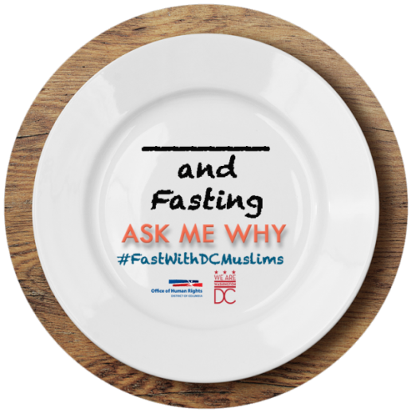
You may have noticed a little “blank space” on the pin (at right). We are asking you to personalize your pin and fill in the blank with a trait or group with which you identify. The intent is to recognize intersectionality amongst many things in our culture from religion to race, sexual orientation to gender, political affiliation to athlete, and much more. Just as much of our identity transcends any one group or association, there are many more layers to Muslims than the faith alone. Here are a few examples: “Yogi and Fasting”, “Black and Fasting”, “Atheist and Fasting”, “Gay and Fasting”
HELPFUL TIP! We found that using a black sharpie to personalize your button will give you clearest “write-in”, though other types of markers may work too!
Further the messages with social media
As a visual statement that you are standing against anti-Muslim discrimination, we encourage you to use your social media to promote the event and spread awareness about our fellow Muslim Americans on June 29 using the hashtag #FastWithDCMuslims.

Example Talking Points
A complete list of talking points can be found in your information packet, but here is a snippet:
I am fasting to help make others aware that…
- Anti-Muslim discrimination should not be tolerated in DC or anywhere else.
- Not all Muslims are Arab and not all Arabs are Muslim. There is much diversity in the Muslim community.
- In the United States, 10 percent of physicians are Muslim Americans, which aligns well with the Islamic obligation of duty towards humanity.
- The best way to learn about the experience of Muslim Americans is to speak with Muslims directly.

We appreciate your support in furthering the message of peace and tolerance in society by standing with our Muslim co-workers, neighbors, friends and family. We are all a part of DC and must make each other feel safe in the place we all belong!

The “FastWithDCMuslims" project is a collaboration between the District of Columbia government, KARAMAH: Muslims Women Lawyers for Human Rights, mosques, Muslim advocacy organizations and allies with the desire to share information about DC Muslims to increase awareness and understanding.

Participating Partners
Asian and Pacific Islander Domestic Violence Resource Project
Collective Action for Safe Spaces
Council on American-Islamic Relations
DC Center for the LGBT Community
Many Languages One Voice
Mayor's Office on African Affairs
Mayor's Office on Asian and Pacific Islander Affairs
Shoulder-to-Shoulder

