The “End the Awkward” project is a one-day campaign in the District of Columbia on July 15 that empowers the public and businesses to share information about disability issues, and to take a pledge to raise awareness and better understand them. The participants are provided a pin that prompts people to ask about how to “end the awkward,” as well as talking points the participant can use to respond. The talking points are intended to instruct people on how to act respectfully toward people with disabilities without being awkward, and are varied in length so they are useful in several scenarios. The project intends to quickly engage people who do not typically think about disability issues, in part so they are primed for the coverage and attention around the 25th anniversary of the Americans with Disabilities on July 26.
Business Engagement
Businesses with employees that have public contact (cafes, restaurants, banks, grocery stores) are encouraged to support the project by asking their employees to study the talking points and wear the “End the Awkward” pin on July 15. Businesses are also encouraged to use their social media to promote the project. Participating businesses will be thanked on the project webpage, social media and the campaign press release.
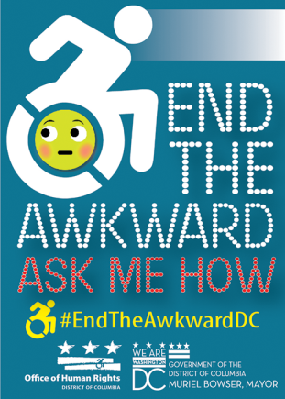
“End the Awkward” Pin
Public Engagement
People with disabilities and allies are encouraged to register online for the project, signaling a commitment to act as a participant on July 15. Participants who register before July 8 will be mailed an “End the Awkward” participant packet, which includes:
- “End the Awkward” pin (at right);
- Talking Points about how to “end the awkward”;
- FAQ sheet of instructions and additional information.
Additionally, participants will be asked to take at least one of several pledges on that day:
- Watching the “Awkward: Disability Sensitivity Training” video and sharing it on social media: The video, which explains appropriate ways to interact with people with disabilities, takes a fun approach to the issues.
- Only traveling accessible routes: By only taking accessible routes for the day, participants will better understand the importance of accessibility to navigating the city successfully.
- Completing “10 Small Ways to Make a Difference” online: The online pledge will ask people to commit to 10 ways to be more aware of issues affecting people with disabilities.
Example Talking Point
“American Sign Language is fun to watch, but if you’re having a conversation with someone who is deaf or hard of hearing, be sure to watch them and not the interpreter.”
- continued on next page –

Social Media
Participants will be asked to share their experiences throughout the day via social media with the hashtag #EndTheAwkwardDC. OHR will email public participants template language and graphics they can use.
Register Online
Public Registration
To register as a participant, visit http://endtheawkwardDC.eventbrite.com. If you register before July 8 and live in DC, Maryland or Virginia, you will receive an “End the Awkward” package by mail which includes your pin, talking points and other materials to prepare for the day.

Business Registration
To register your business as a participant, visit http://endtheawkwarddc-business.eventbrite.com. Your business name will be included as a participant on the webpage and in press materials, and pins and talking point materials will be sent to your business (if registered before July 8).

For more information about the campaign, visit http://ohr.dc.gov/page/endtheawkwardDC.

Partner Agencies and Organizations
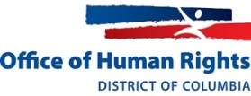 | 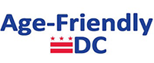 | 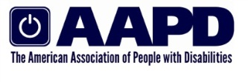 | 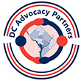
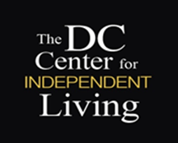 |  | 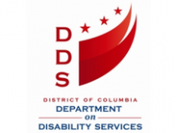 | 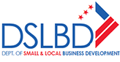
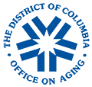 | 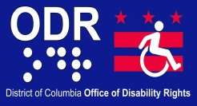 | 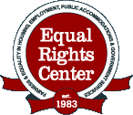
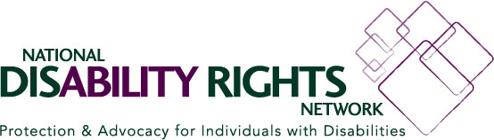 |  | 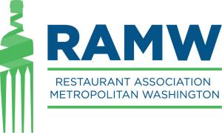
 | 