Thank you for agreeing to participate in the “End the Awkward” campaign.
We know people sometimes hesitate to interact with people with disabilities because they fear making a mistake or saying something incorrectly. Together, our job will be to “end the awkward” around these interactions by providing useful tips to people who may not think about disability issues as well as becoming more mindful of them ourselves. There are many efforts happening around the city today, from sharing tips on how to respectfully interact with people with disabilities, to committing to 10 small ways to make a difference.
#AccessiblePathDC
We’re excited you have decided to take the pledge to travel exclusively by accessible routes today! You will have the unique opportunity to explore accessible paths throughout the city, using only accessible methods to work, dinner, happy hour, or home. You may realize your daily routine may change a bit (or a lot!). When looking for accessible paths, consider the following:
- Walking around town: If you normally travel by foot, be mindful to use only curb cuts (ramps on the corner of sidewalks) to get on and off the sidewalk, and be sure to bypass damaged or obstructed sidewalks that could not be circumvented by a wheelchair.
- Public Transit: Make sure to only take the elevator at Metro stations to enter and exit platform. If elevators are out, the only accessible path is to take the train to a station with a working elevator and taking the shuttle bus back to the intended station.
- Restaurants/Cafes/Shops: Whether grabbing coffee with a colleague, getting to a dinner reservation, or using your lunch for some shopping therapy, be sure not to climb any steps into the establishment. You will need an accessible entrance – such as one with a ramp or no steps – to enjoy the place.
While you’re out and about, don’t forget to tweet us @DCHumanRights using #AccessiblePathDC and/or #EndTheAwkwardDC and let us know how your day is going!
Find additional information about the pledges at http://ohr.dc.gov/page/endtheawkwardDC.

Partner Agencies and Organizations
 |  |  | 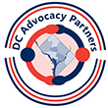 | 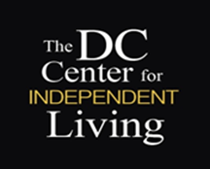 |  | 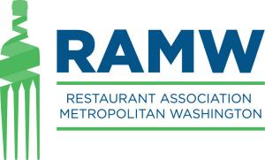
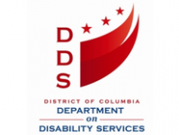 |  | 