Thank you for agreeing to participate in the “End the Awkward” campaign.
We know people sometimes hesitate to interact with people with disabilities because they fear making a mistake or saying something incorrectly. Together, our job will be to “end the awkward” around these interactions by providing useful tips to people who may not think about disability issues as well as becoming more mindful of them ourselves. There are many efforts happening around the city today, from sharing tips on how to respectfully interact with people with disabilities, to moving throughout the day solely using accessible routes.
10 Small Ways to Make a Difference
You don’t always have to go to extraordinary measures to truly make a difference. Sometimes it is the small adjustments we make along the way that have the greatest impact. Here are a few ways you can be more mindful of people with disabilities:
- Do not use parking spots or priority seating on public transportation that is reserved for people with disabilities – even if there are numerous spots available – unless you are a person with a disability.
- If you think a person with a disability may need assistance, just ask if you can be of help.
- When you hear other people focusing on a person’s disability instead of on the person themselves, encourage them to think differently. Help them realize people with disabilities have ordinary lives, and have hopes and dreams that are similar to anyone else.
- Ignore service animals when they are working – do not pet, feed or distract them from their job.
- Understand disabilities are often hidden or invisible. Don’t assume that because you don’t see a disability the person can’t have one. Simply treat others the way they should be treated.
- Avoid using common phrases that may associate an impairment with negative things or behavior, such as “fallen on deaf ears” or “blind drunk”.
- Encourage restaurants and bookstores to carry large-print and braille menus and books.
- Hold open doors for people in wheelchairs or people who have crutches.
- Speak at a normal volume and pace when talking to people with disabilities.
- Remove labels like “handicapped”, “disabled”, and “slow” from your vocabulary when referring to people with disabilities. These terms can be offensive and doesn’t define a person’s identity.
While you’re out and about, don’t forget to tweet us @DCHumanRights using #EndTheAwkwardDC and let us know how your day is going! Find additional information about the pledges at http://ohr.dc.gov/page/endtheawkwardDC.
Partner Agencies and Organizations
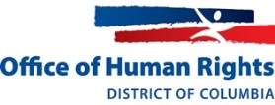 | 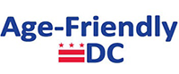 | 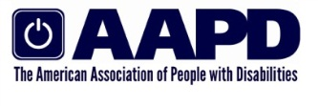 | 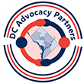 | 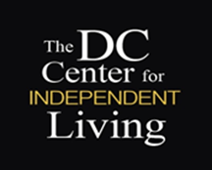 |  | 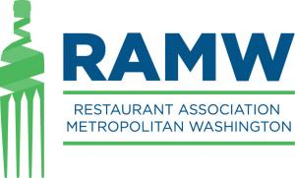
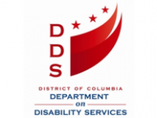 | 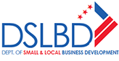 | 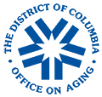 | 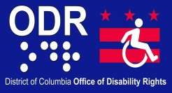 | 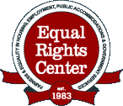 |  |  | 